-By clicking on the Patient Explorer Application, it is displaying the Dialog window mentioned in the F.S

- It should be possible to minimize, resize and maximize the patient explorer dialog window manually and using qtp , qtp script is shown below :

- SwfWindow("PatientExplorer").Activate

- SwfWindow("PatientExplorer").Maximize

- SwfWindow("PatientExplorer").Minimize

- SwfWindow("PatientExplorer").Resize

UID:

1. I cannot test application like this, because it is throwing error if I pass negative value and also positive value, if I pass positive value and filling complete patient explorer window and click on save it is not throwing error. Check few screen shots of the application mentioned below:

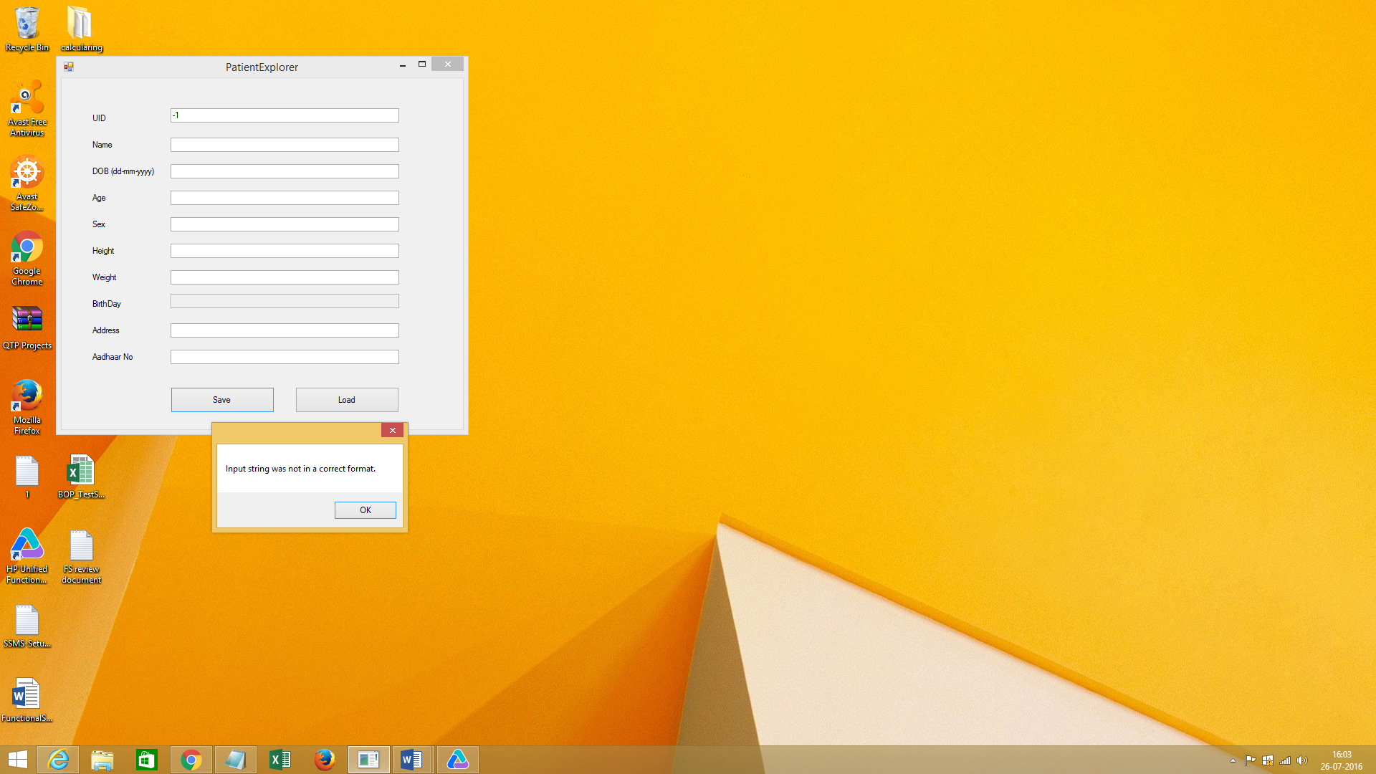

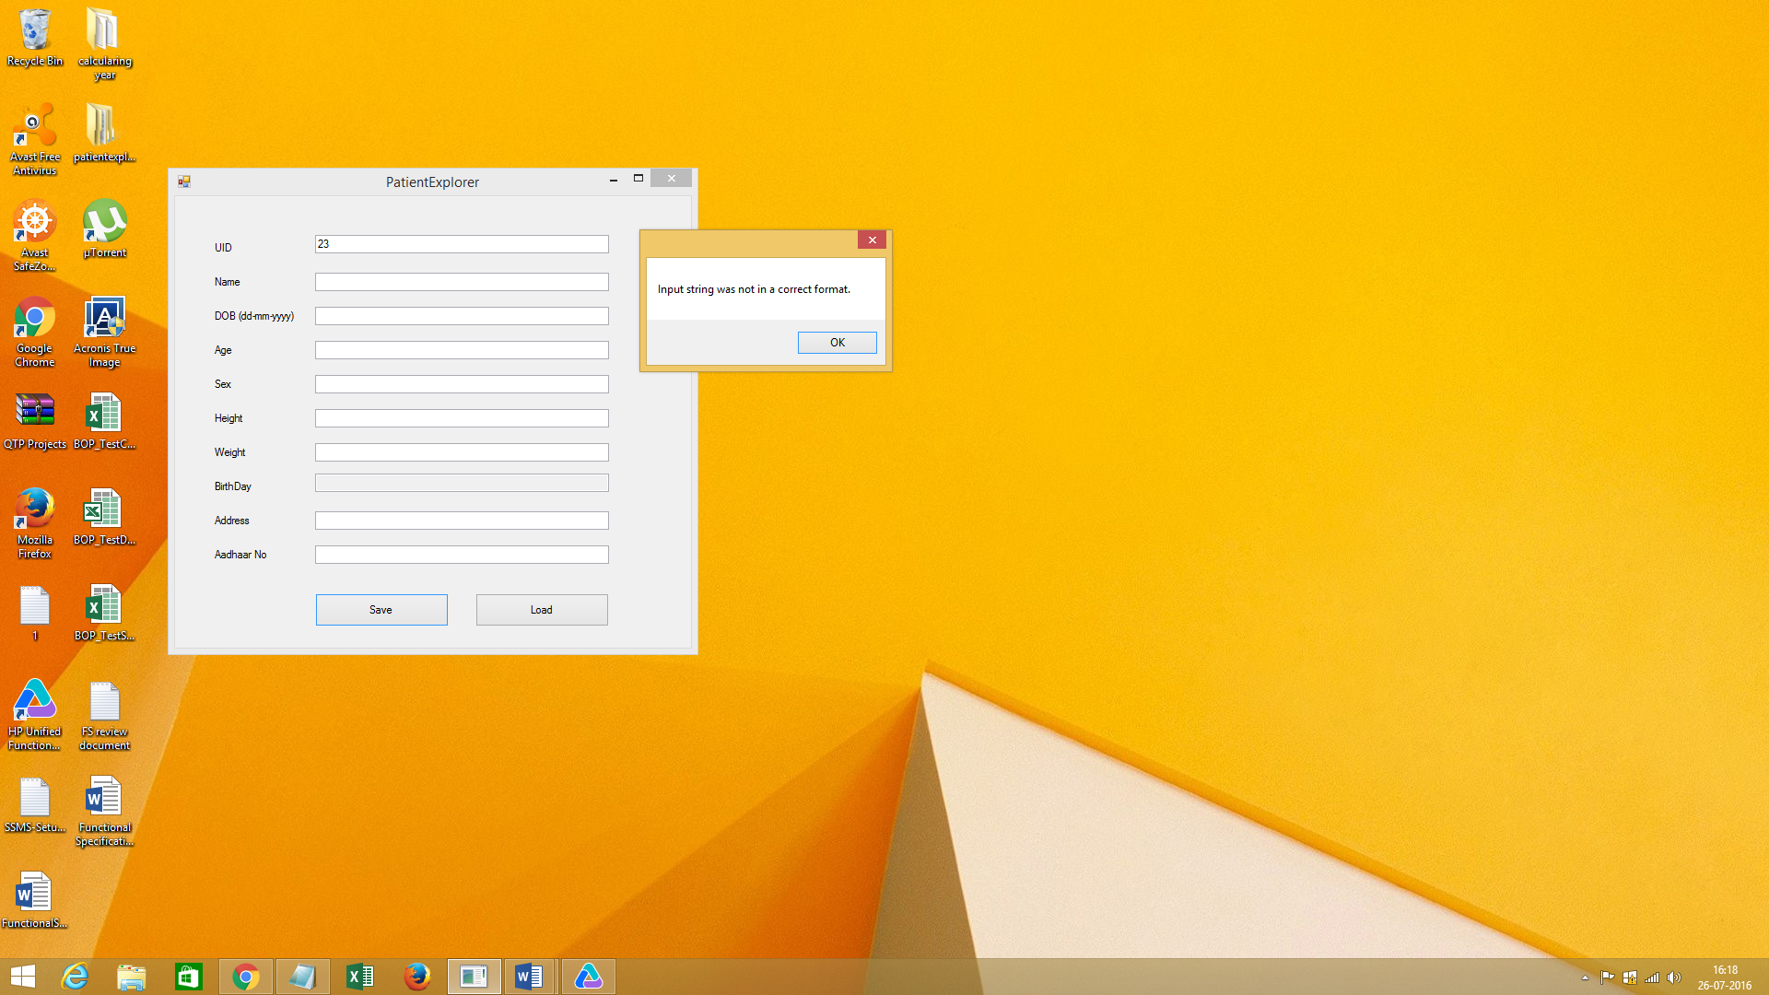

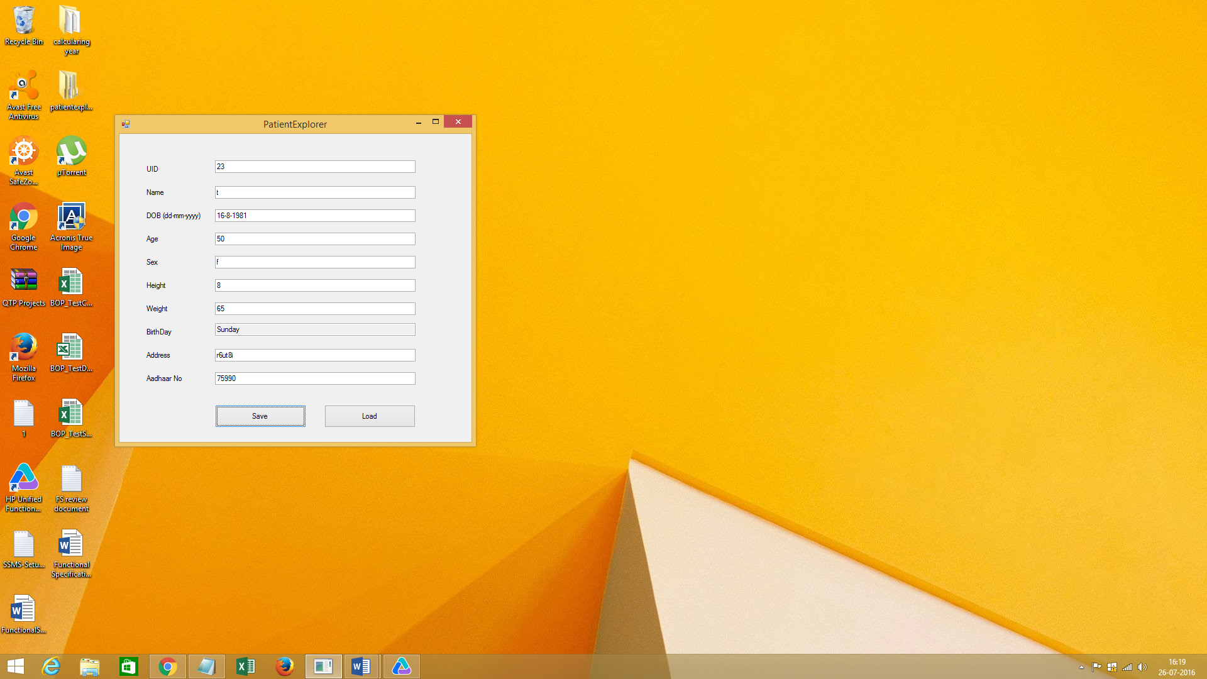

**Name:**

1. **Name field in PatientExplorer not accepting numbers**

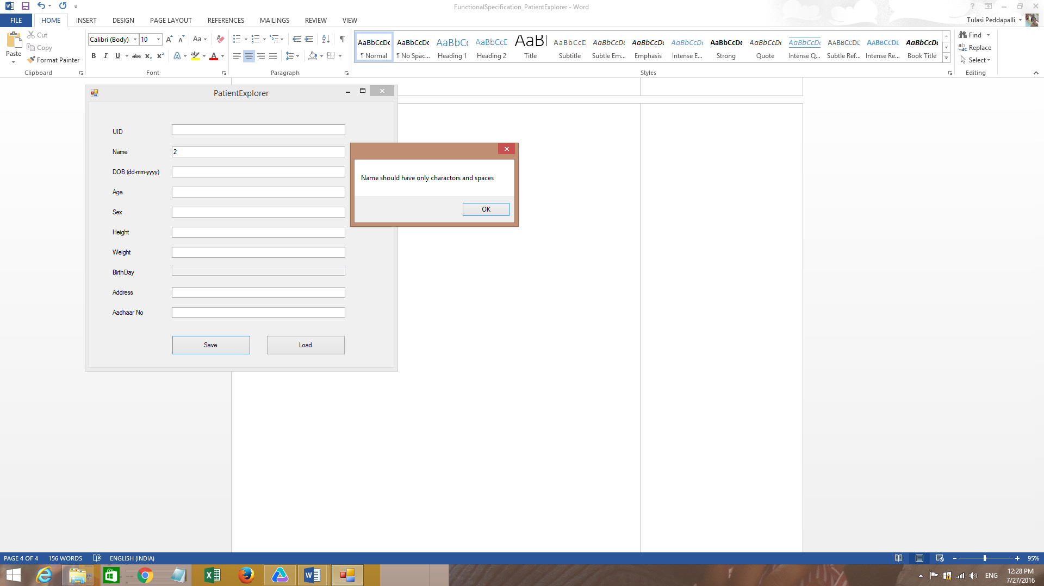

**DOB:**

* **It is accepting greater than present year**

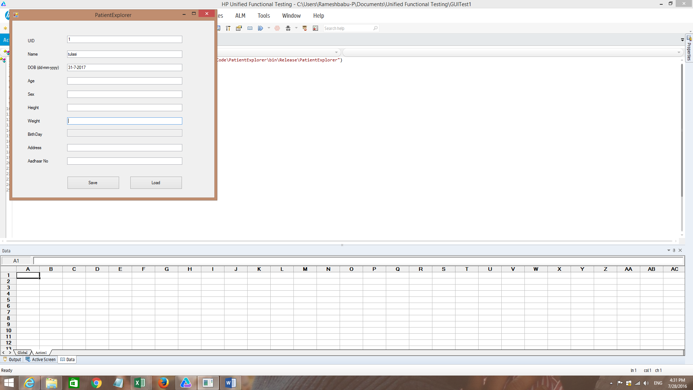

**Age: If I am given characters it is giving error as shown in below image**

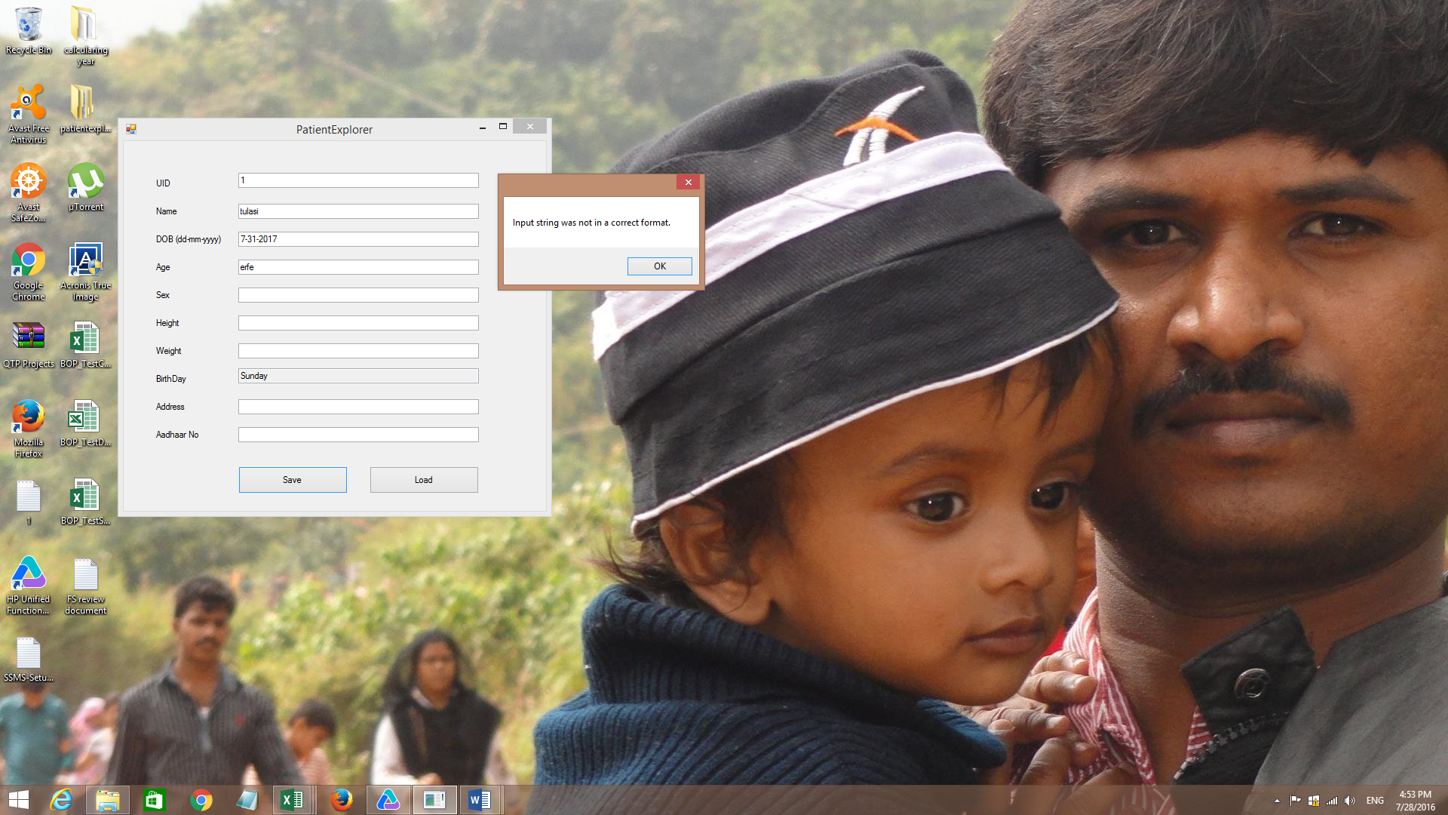

**DOB: FOR ANY DOB FORMAT IT IS SHOWING ERROR**

